<!DOCTYPE html>

<html lang="en">

<head>

<meta charset="UTF-8">

<meta name="viewport" content="width=device-width, initial-scale=1.0">

<title>RESITER FORM</title>

<link rel="stylesheet" href="kishore.css">

<body background=""></body>

</head>

<body>

<form>

<div>

<h1><b>REGISTRATION FORM</b></h1>

<label for="first-name">First Name</label><br>

<input type="text" id="first name" name="first name" required><br>

</div>

<div>

<label for="last-name" >Last Name</label><br>

<input type="text" id="last-name" name="last name" required><br>

</div>

<div>

<label for ="user Name">User Nmae</label><br>

<input type="text" id="username" name="username" required><br>

</div>

</div>

<label for="email">E-mail</label><br>

<input type="email" id="email" name="email" required><br>

</div>

<div>

<label for="tel">tel phone number</label><br>

<input type="tel" id="tel" name="tel" required><br>

</div>

<div>

<label for="password"> password</label><br>

<input type="password" id="password" name="password" required>

</div>

<div>

<label for="conform-pasword">conform password</label><br>

<input type="password" id="conform-password"name="cpassword" required><br>

</div>

<button>SUBMIT</button>

</form>

</body>

<html>

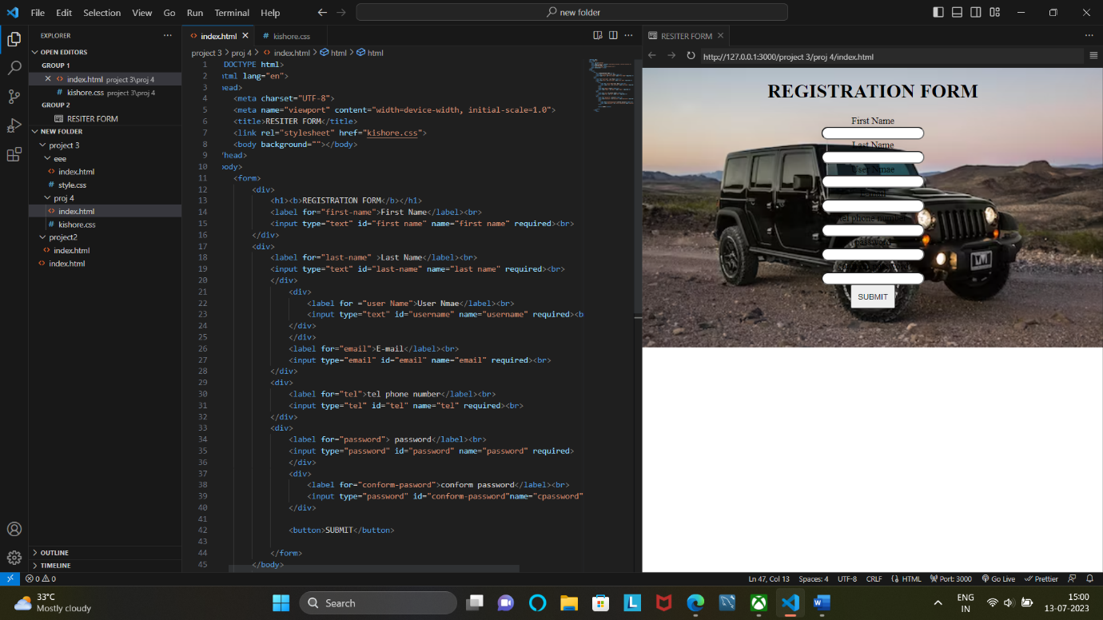

body{

background-image: url(https://images.unsplash.com/photo-1506015391300-4802dc74de2e?ixlib=rb-4.0.3&ixid=M3wxMjA3fDB8MHxzZWFyY2h8MXx8YmxhY2slMjBqZWVwfGVufDB8fDB8fHww&auto=format&fit=crop&w=500&q=60);

background-repeat: no-repeat;

background-size:cover

}

h1, p{

text-align: center;

}

input{

border-radius:67px;

}

form{

text-align: center;

}

button{

color: rgb(6, 12, 12);

padding: 0.75em;

}